Context Exploration Service
This annex provides additional technical details about the chat service, which enables natural language communication with DiverSea repositories and environments for exploring the data, the data sources and geolocations as well as more generally the project activities relevant to them. It has been implemented by utilization of the recent advances in AI embodied in LLM technologies and can be reached at https://chatbot-diversea.gate-ai.eu. Fig. 5 shows the exploration of the Atlantic Coast of Portugal using the DiverSea chatbot and Tab. 4 summarizes the command protocol.
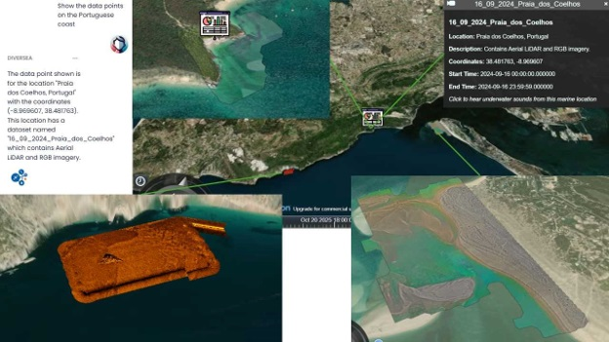
Figure 5. Atlantic Coast Exploration using DiverSea Chatbot (https://chatbot-diversea.gate-ai.eu)
Operation | Parameters | Description | Tools
Request  formulation | Project context,  Search space,  Natural language | Map navigation, Spoken and  written text in natural language, Multi-lingual support | TypeScript  React, NodeJS  Whisper
Spatial  navigation | Geolocation  coordinates | Obtaining the geographic location coordinates from the map | Cesium
Information retrieval | Institutions, Events,  Meetings, Activities, Locations, Histories | Keyword-driven query analysis, Search space contextualizing, Query formulation | Odrant,  vLLM,  Qwen3-32B
Information  presentation | Geospatial actions,  Spoken text,  Written text | The information is represented visually on the map, accompanied by a written textual description | Kokoro,  Cesium,  TypeScript
Table 4. Chatbot Operations and Parameters
Any problems related to the functioning of the service can be directed to the service administrator (email: boris.kraychev@gate-ai.eu).

